בס"ד

**Final Project**

Leah Pines

<https://github.com/LeahPines/ugg-online-store-react.git>

**Part 1: Deploy App to Cloud Run**

***Step 1: Docker Image***

● **Commands Used: \*** docker build -t leahpines/my-updated-app:latest .

**\*** docker push leahpines/my-updated-app:latest

● **Screenshot**:

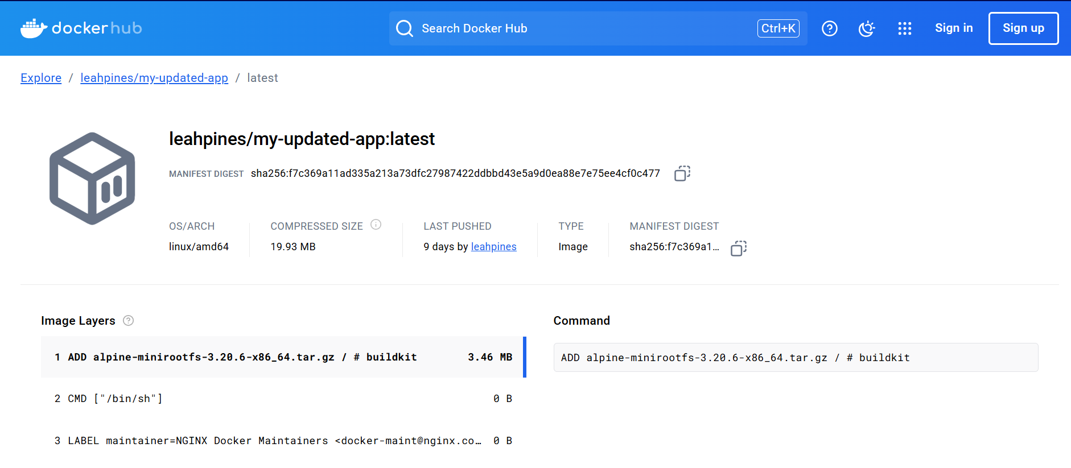

***Step 2: Deploy to Cloud Run***

● **Service Name and Region:** html-project, me-west1

● **Screenshot**:

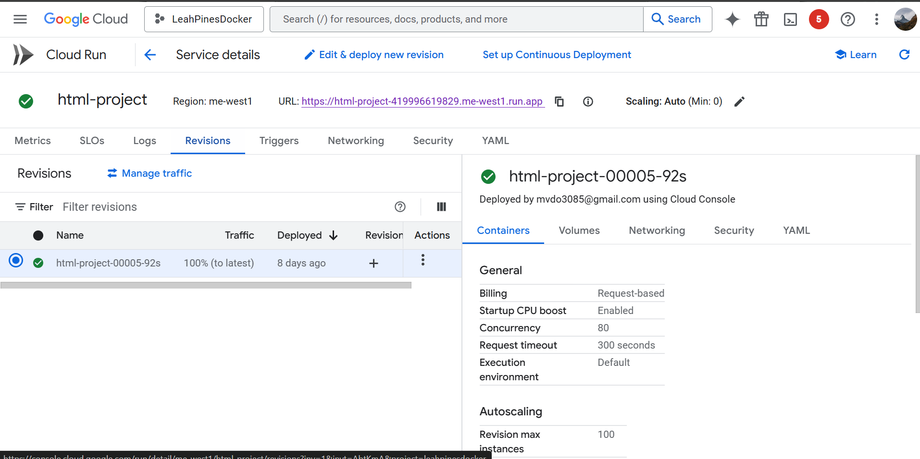

● **Public URL**: https://html-project-419996619829.me-west1.run.app

● **Screenshot**:

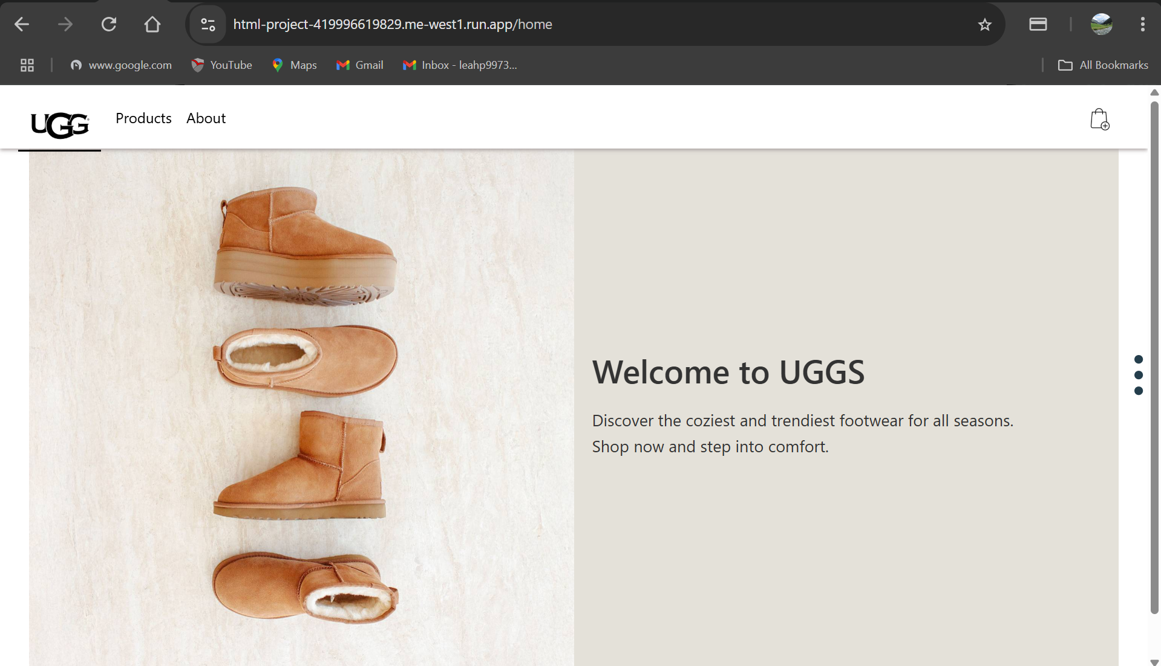

**Part 2: Enhance App**

**Option 1: Cloud Storage Integration**

1. **Bucket Name**: docker-app-bucket

2. **Screenshot**:

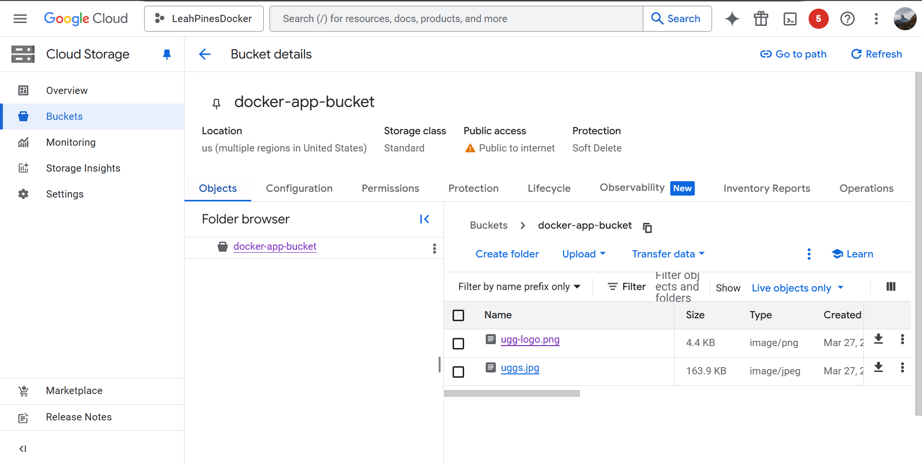

**3.** **Screenshot**:

